**DAILY ONLINE ACTIVITIES SUMMARY**

|  |  |  |  |  |  |  |  |
| --- | --- | --- | --- | --- | --- | --- | --- |
| **Date:** | **4/06/2020** | | | | **Name:** | **Shashikant Chavaan** | |
| **Sem & Sec** | **8th- B** | | | | **USN:** | **4AL16CS090** | |
| **Online Test Summary** | | | | | | | |
| **Subject** | | **SMS** | | | | | |
| **Max. Marks** | | **60** | | **Score** | | **50** | |
| **Certification Course Summary** | | | | | | | |
| **Course** | **Python Programming in Hindi** | | | | | | |
| **platform** | | | **GreatLearning** | **Duration** | | | **3 hours** |
| **Coding Challenges** | | | | | | | |
| **Problem Statement :**  **Python program to find HCF of two numbers.** | | | | | | | |
| **Status: Executed** | | | | | | | |
| **Uploaded the report in Github** | | | | **Yes** | | | |
| **If yes Repository name** | | | | https://github.com/alvas-education-foundation/Shashikant_chavan | | | |
| **Uploaded the report in slack** | | | | **Yes** | | | |

Online Test Details:

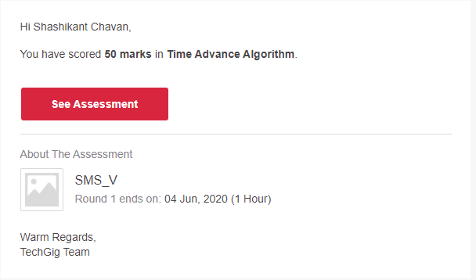

Certification:

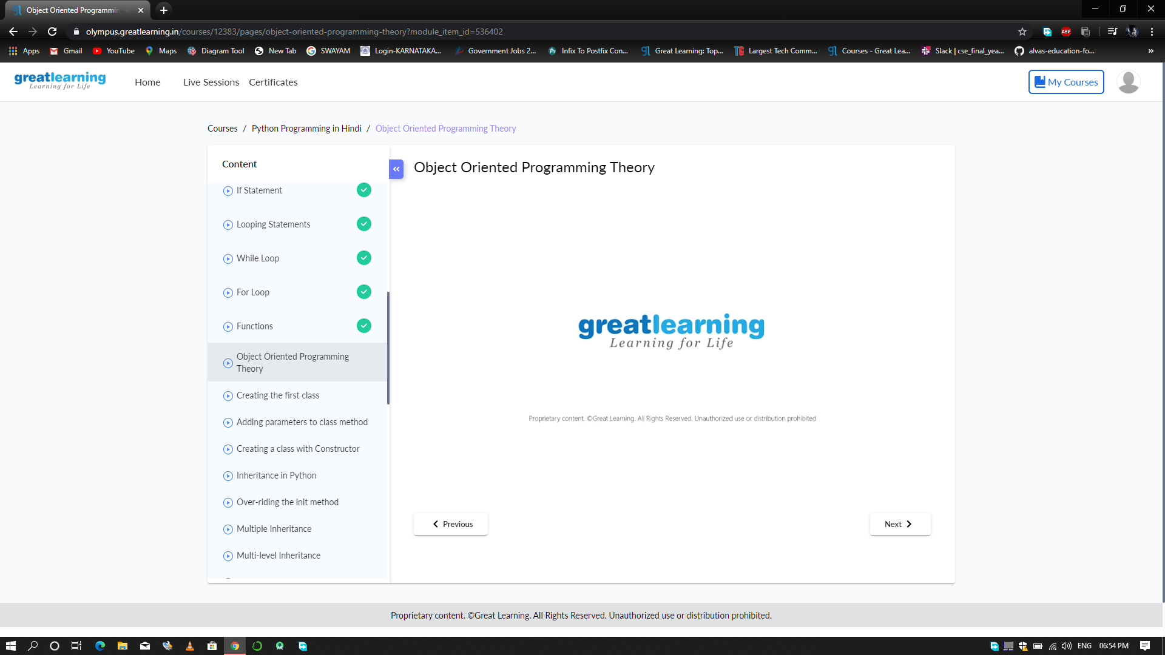

Coding Challenges Details:

Coding Challenges Details:

defcompute_hcf(x,y):

ifx>y:

smaller=yelse:

smaller=xforiinrange(1,smaller+1):

if((x%i==0)and(y%i==0)):

hcf=ireturnhcf

num1=54

num2=24

print("TheH.C.F.is",compute_hcf(num1,num2))